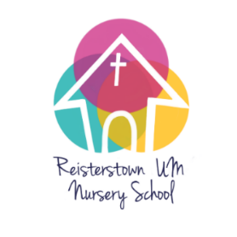

**Reisterstown United Methodist Nursery School 2024-2025 Preliminary Calendar \***

August 2024 7 Meet and Greet on Playground 5:30 - 7:00 p.m.

**28 Parent Meeting in Church library 6:30 pm**

September 2024 2 Labor Day

**3 School starts all classes**

October 18 Maryland State Teacher Conferences (MSDE) – closed

School Picture Day

November 1 Pajama Day

15 Church event - closed

27, 28, 29 School closed – Thanksgiving

December 14 Breakfast with Santa Fundraiser

19 All school Christmas program 11:00

21-31 School closed for Christmas –

January 2025 1 Closed for New Years

**2 School reopens**

20 School closed for MLK

February 17 School closed for President’s Day

March

April 11- school closed for Parent conferences

14-20 SCHOOL CLOSED for spring break

**21 school reopens**

May 9 4’s class Mother’s Day lunch – half day for 4 year olds

26 School closed for Memorial Day

June 13 4’s graduation 11:30 – Church Sanctuary –

13 Last day of school – HALF DAY ALL STUDENTS 13 School picnic –12:00 – 1:30 – front lawn of the Church

* Calendar dates are subject to change. Updated 1/10/24 -